HANDS-ON 6
Services & Dependency Injection
Task 1: Create and Use a Course Service Goal: Build a CourseService that provides course data to multiple components
Creating Course interface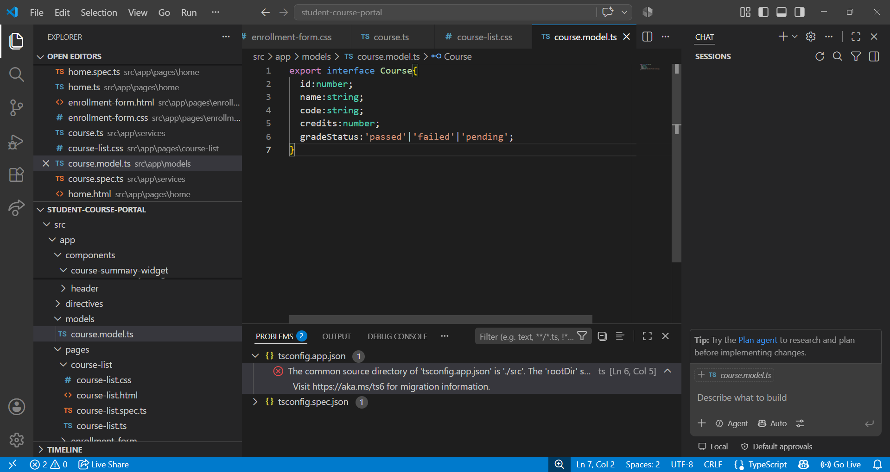

Injecting Course service in course list
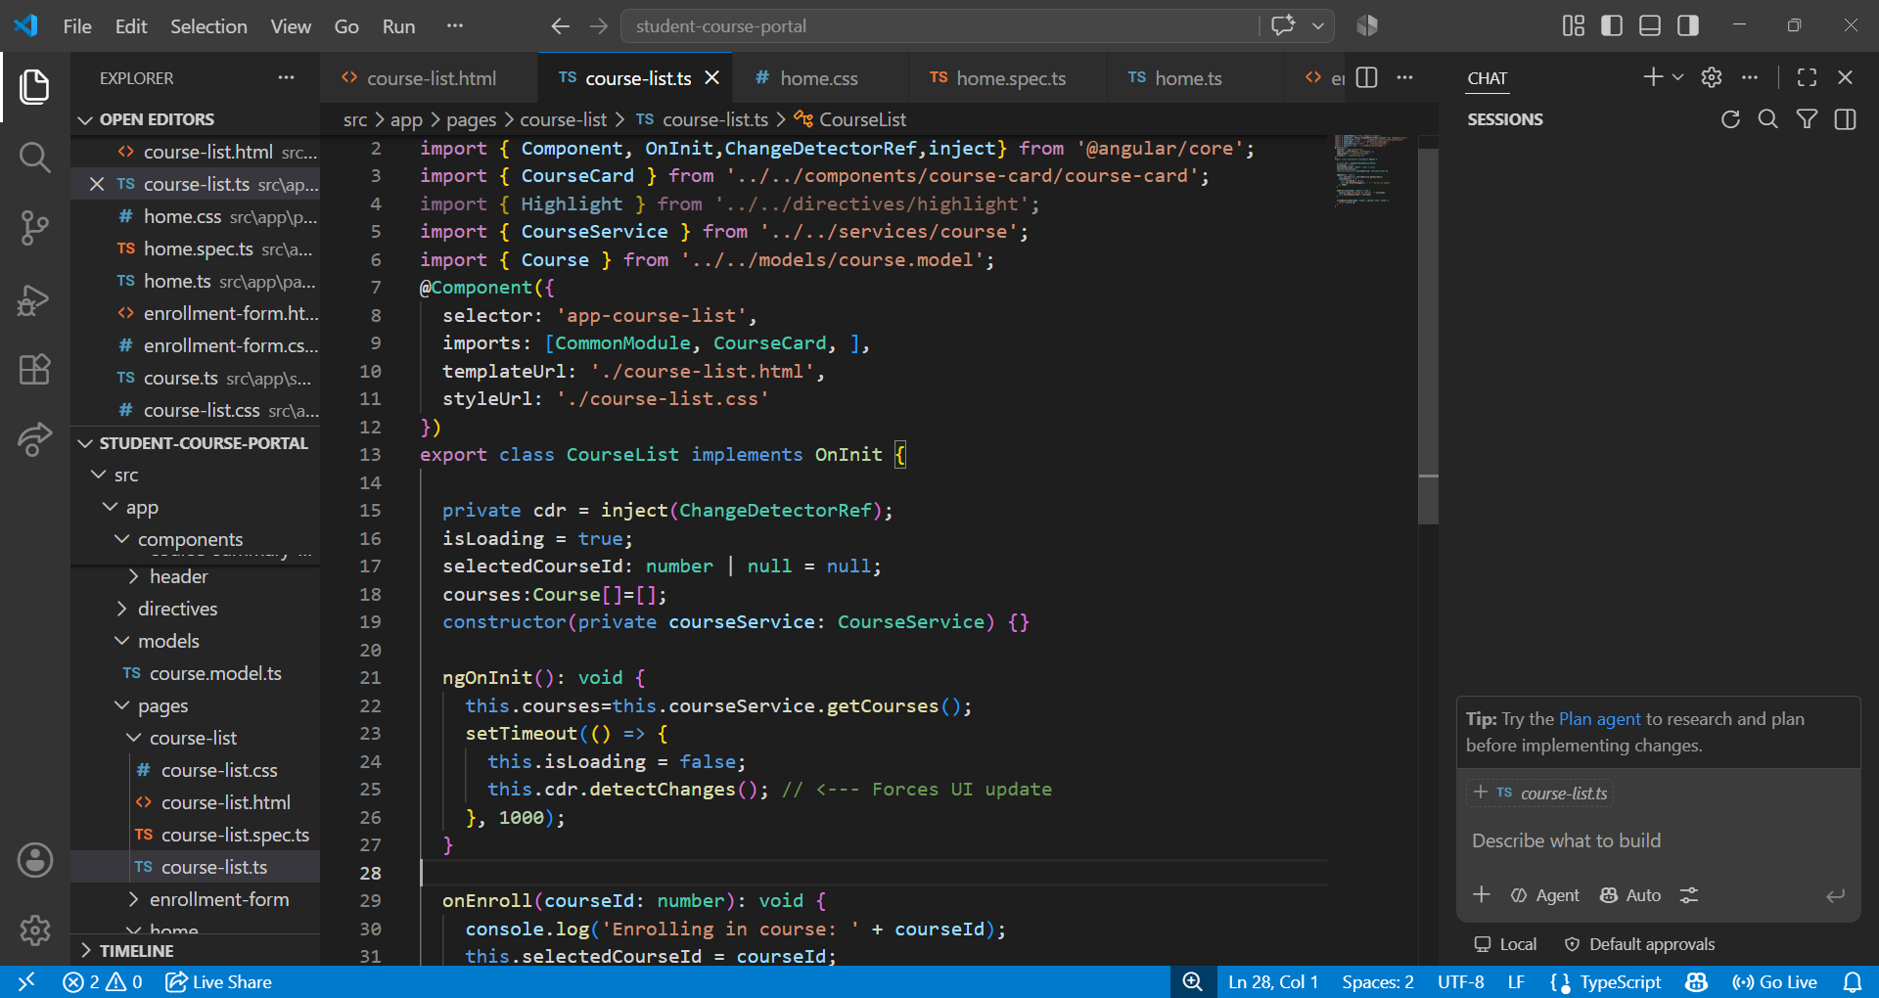

Injecting course service in home
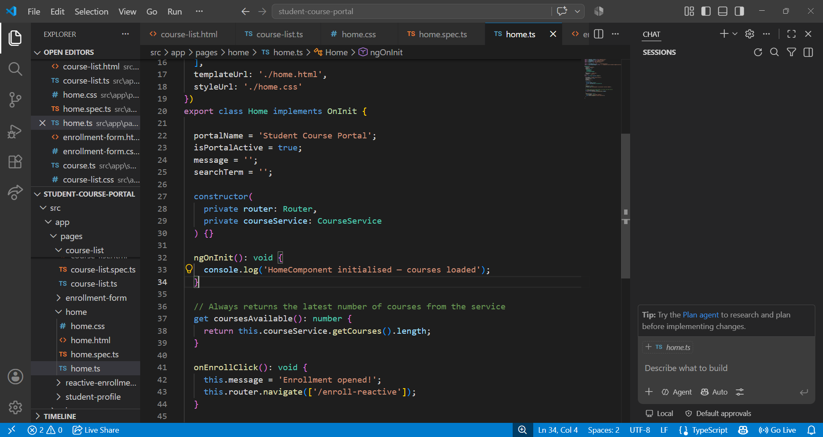
Course summary
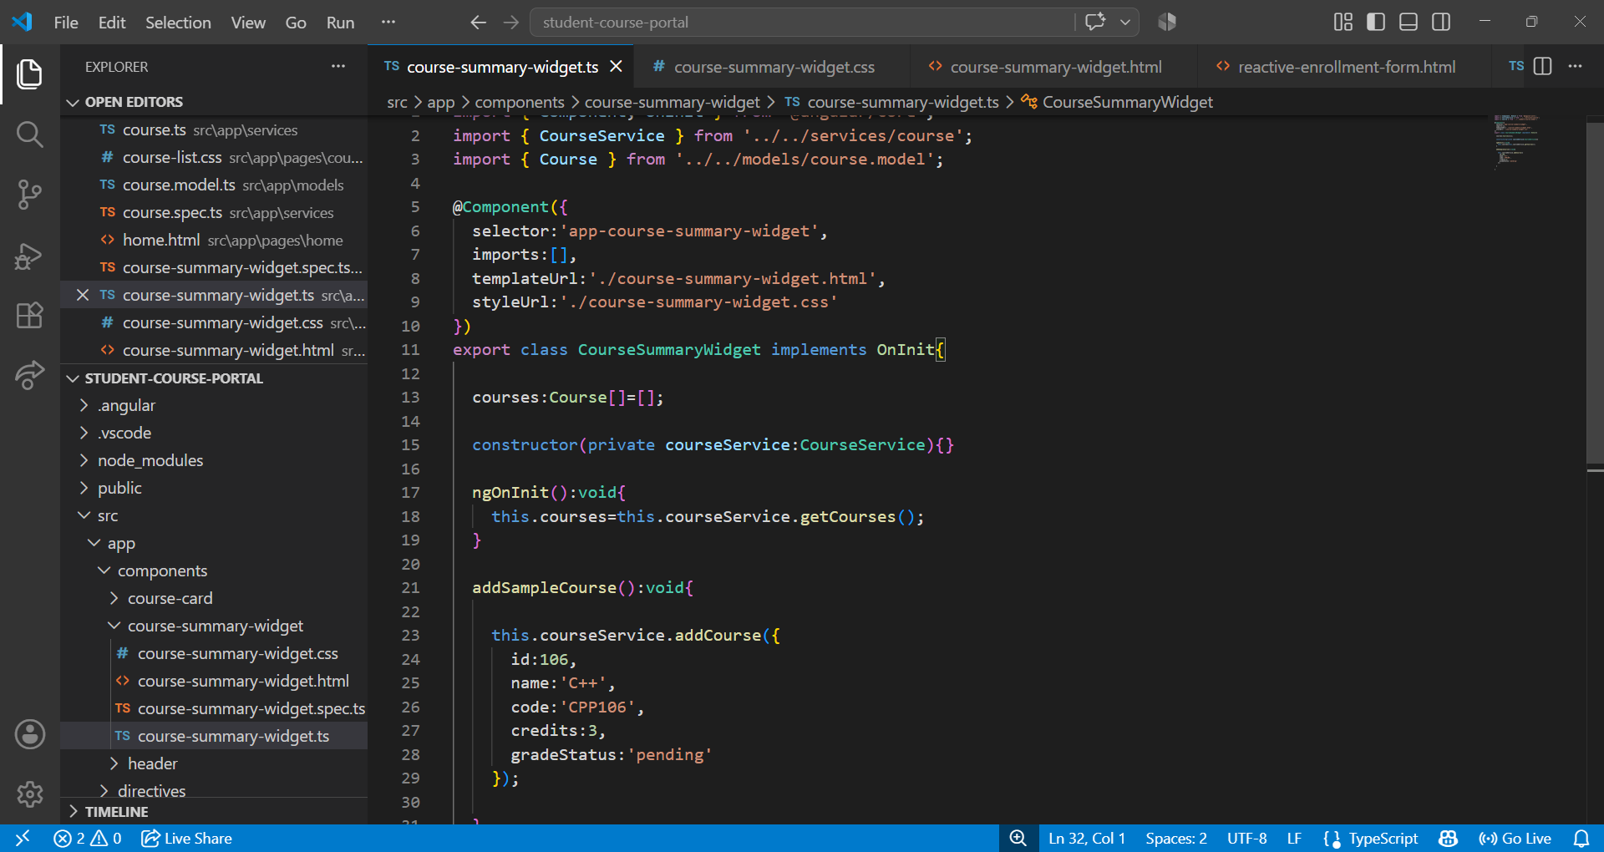

Output
Course available changed when sample course added
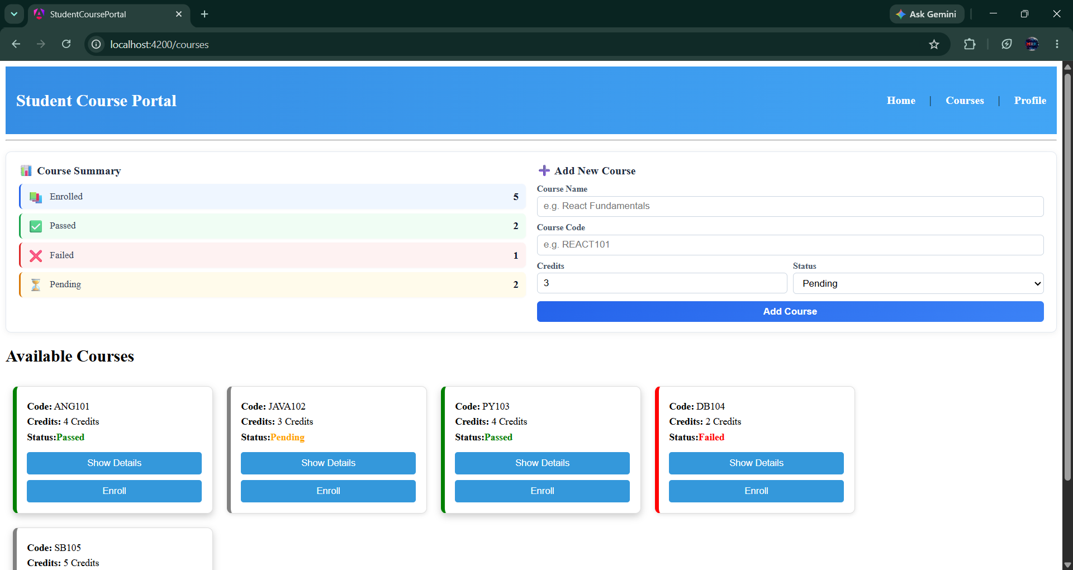

Course added and summary changed
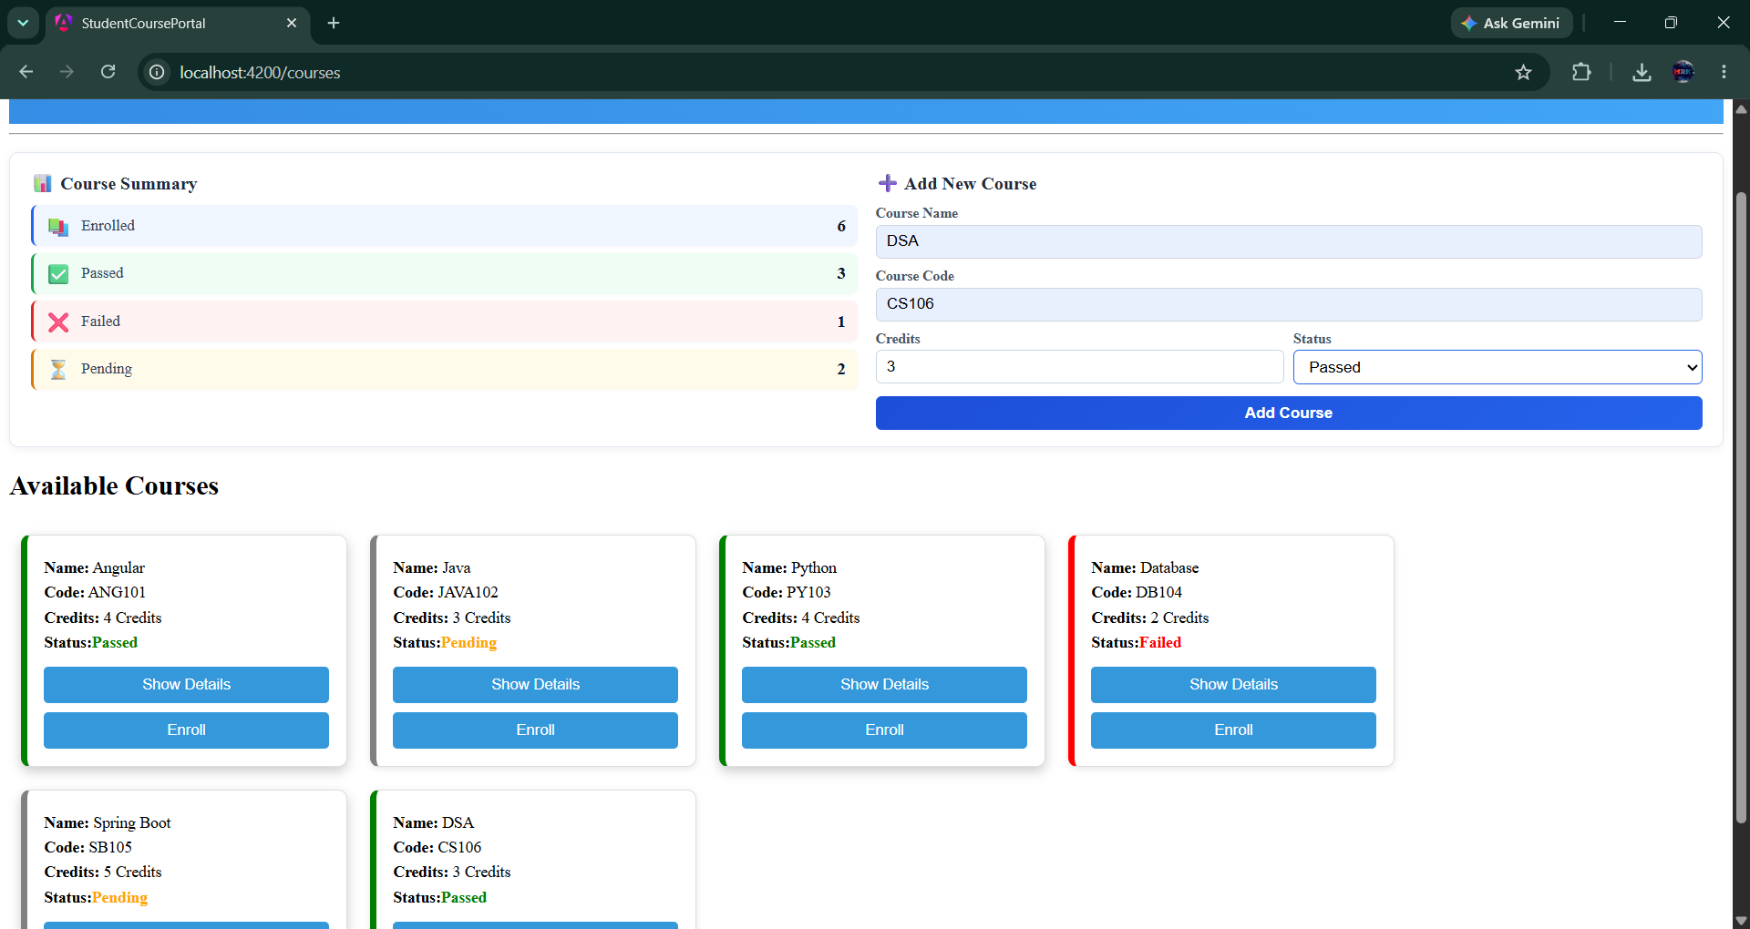

Task 2:
Creating enrolment service and injecting course service
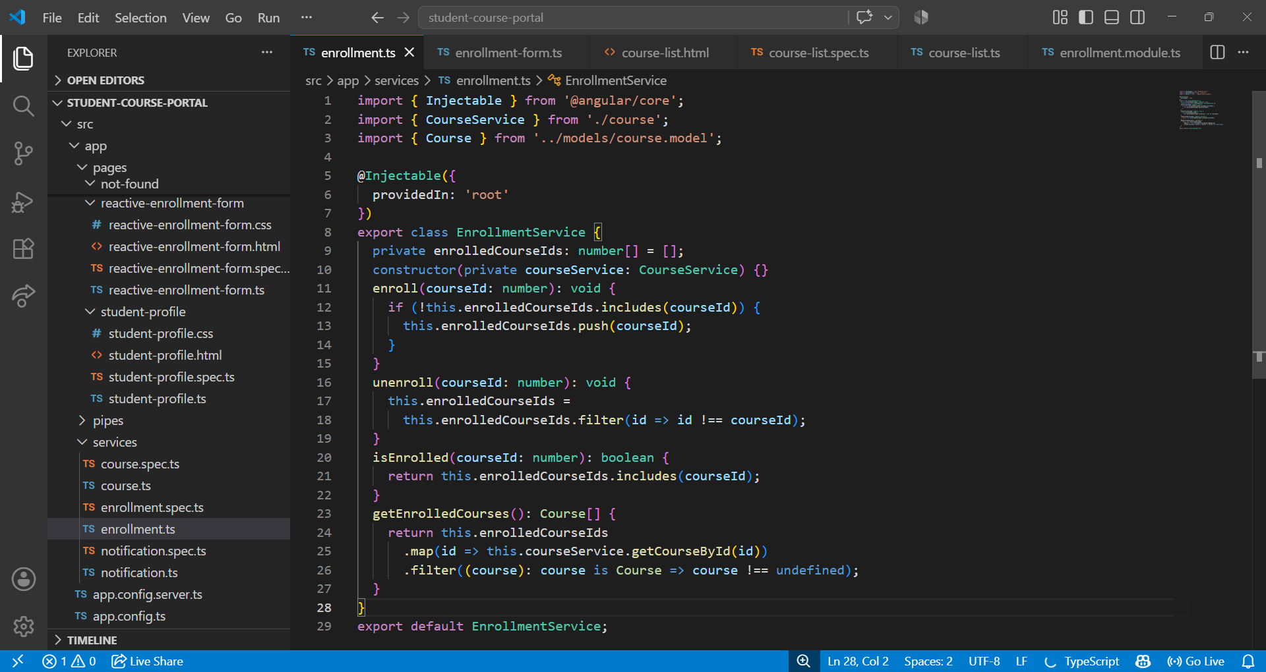

Injecting courseService in courselist component
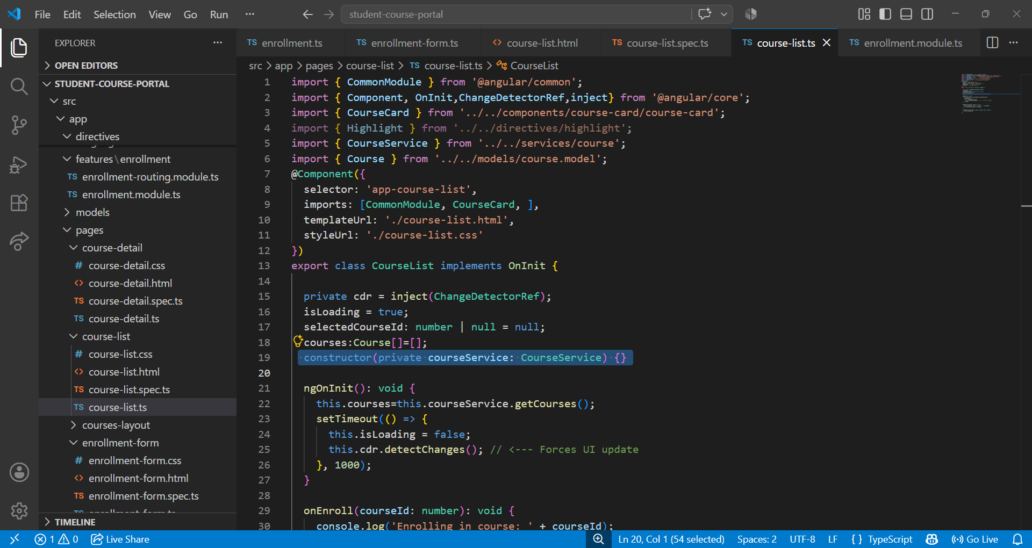

Injecting CourseService in courselist
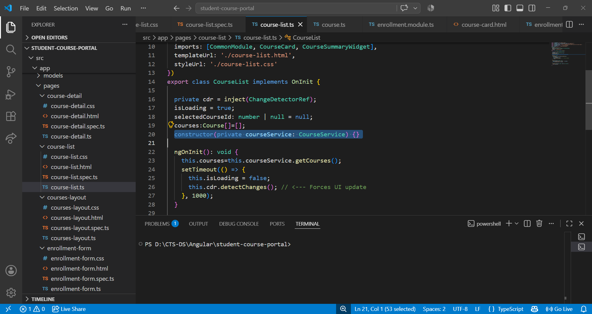
Implementing enroll and unenroll of course
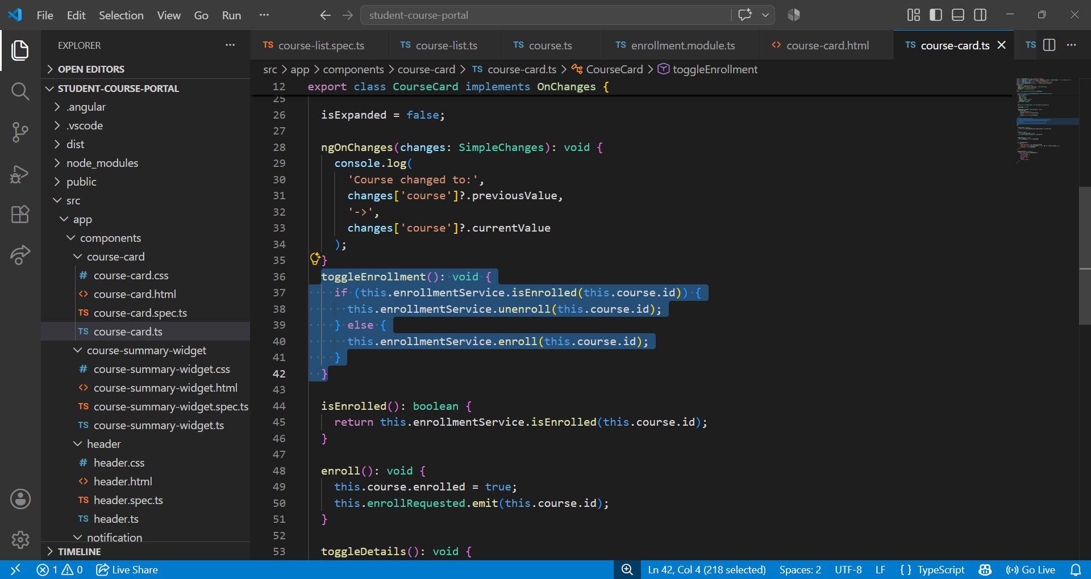

Student Profile html
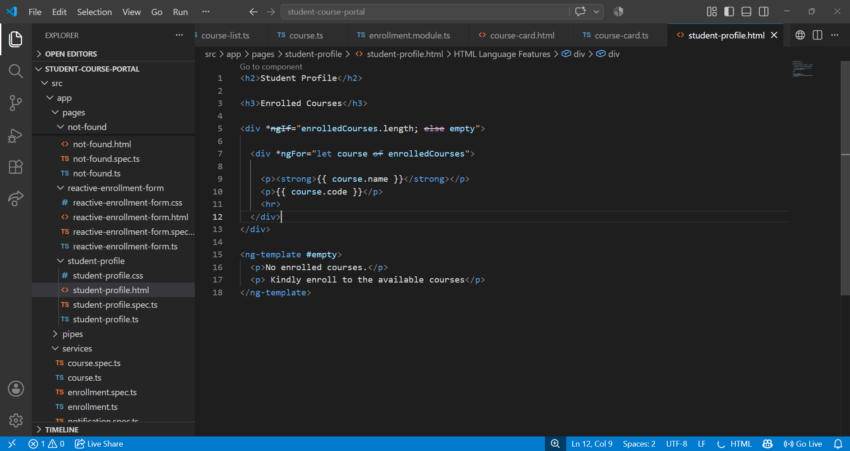
Student Profile ts
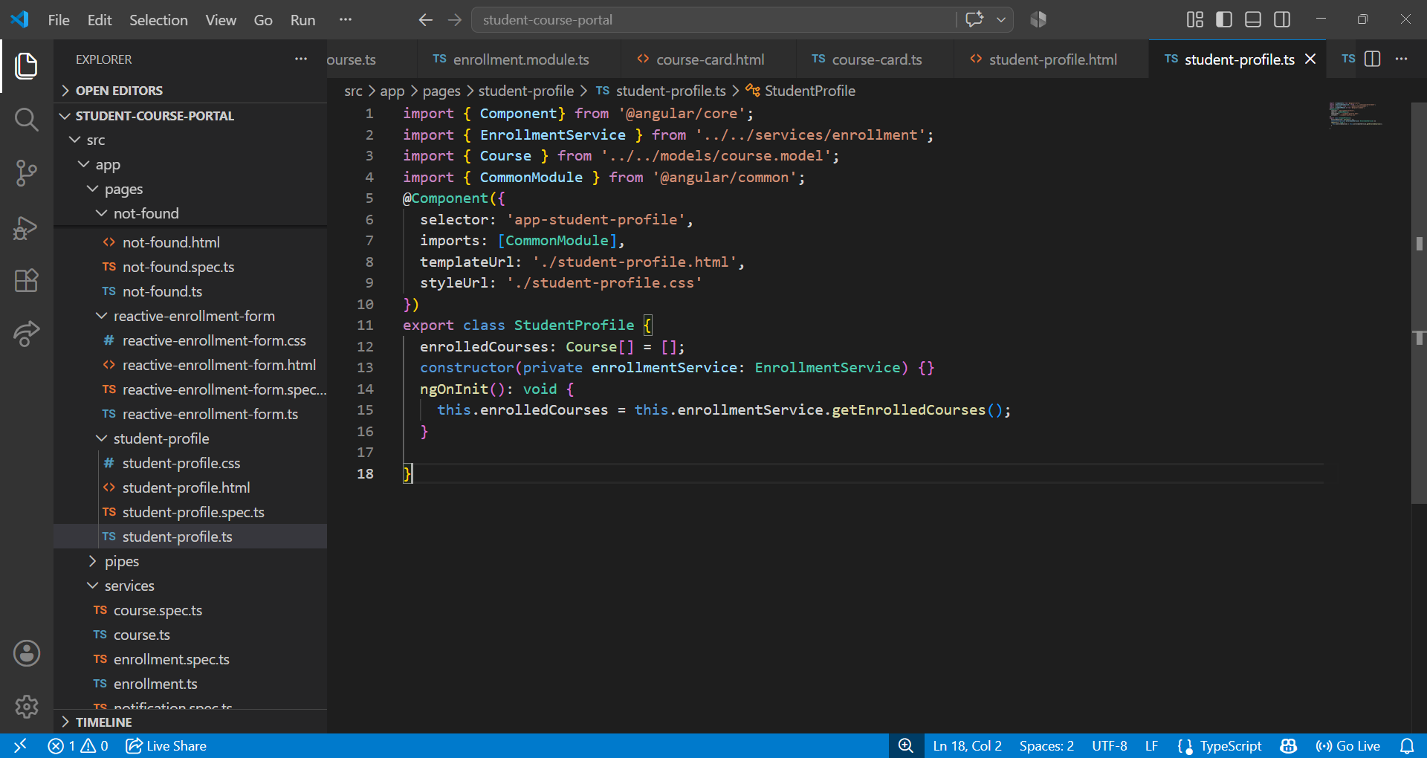

Enrolled to python course is displayed
